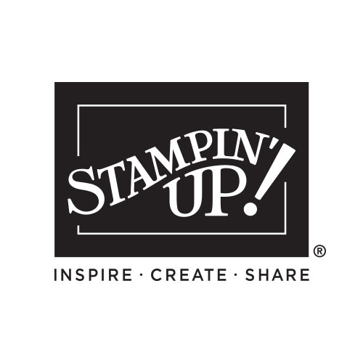

2026 May-August

CATALOG INDEX

New & Trending 2-3
Message from Sara 4
Table of Contents/Icons 4
Stampin’ Snippets 5-7
Step by Step 8-9
Quick & Easy 10-13
Creativity Your Way 14-35
Suites Collection 15-35
- Bloom Boutique 16
- Heirloom Boutique SWK 19
- Waterside Retreat 20
- Valley in Bloom 22
- Life in Bloom SWK 25
- Scenic Coast 26
- Beautiful Ordinary Life 28
- Extraordinary Life SWK 31
- Velvet Meadow 32
- Moonlit Flora 34
Bundles 36-42
Perfectly Placed (Stamp Positioner) 43
Stamp Sets 44-56
Stampin’ Cut & Emboss 57
Dies 58-60
Embossing Folders & Punches 61
DSP (Designer Series Paper) 62-66
Paper & Envelopes 67
Mix & Match 68-70
Memory Keeping 71
Embellishments & Trim 72
Adhesives 73
Tools & Inks 74-77
New In Colors 78-79
Color Collections 80-82
Index 83-85
Angel Policy/Legal 85
Rewards 86
Join 87

Please keep this list - mark off things as you purchase them OR give this list to someone who loves you so they can purchase gifts for you!

My Wish List

Name:_____________________________

QTY | Code | Description | Page | Price
Order Anytime! Shop Online 24/7!
Contact me with questions or to place an order:

Your Name Here
City, State Zip Code
Phone number and email address
Free ideas on my blog/website:
Blog or Website address

