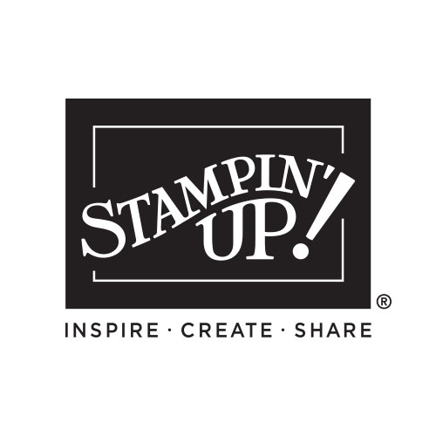

2025-2026 ANNUAL

CATALOG INDEX

Message from Shelli and Sara Inside Cover
Icons 2
Table of Contents 3
Making a Difference 4
Gathering 5
Find Your Reason to Craft 7
Rewards 8
Step-by-Step Crafting 9-21
- Kits Collection 10-12
- Scrapbooking Workshop Kits 13-21
Join the Challenge 22
Quick & Easy Options 23-37
- Mix & Match 24-29
- Memories & More 30-31
- Quick Ink 32-33
- Stamp Sets 34-37
Creativity Your Way 38-101
Suite Collections 40-63
- Florals in Bloom 40-47
- Turtley Cute 48-51
- Beautiful Gallery 52-57
- Kintsugi Inspirations 58-60
  - Boho Vibes 61-63
Scrapbooking From Scratch 64-79
  - Memories in Bloom 66-67
  - Turtley Sweet 68-69
  - Celebrate Together 70-71
  - Weekend Adventures 72-73
  - Flip Flaps 74
  - Albums 75
  - Two-Tone Cardstock 76-77
Stampin’ Cut & Emboss 80
Bundles 81-87
New Stamp Sets 88-97
Returning Favorites 98-101
Tools 102-103
Punches 104-105
Dies 106-107
Embossing Folders 108-109
Acrylic Blocks/Cleaners 110-111
Adhesives 112-113
Specialty Paper & DSP 114-121
Envelopes 123
Embellishments/Ribbon/Trim 124-127
Blending 128-129
Specialty Inks 130-131
Embossing 132-133
Color 134-139
  - Color Collections 137-139
Paper Pumpkin 140
Join 141
Index 142-143
Angel Policy/Legal 144

Please keep this list - mark off things as you purchase them OR give this list to someone who loves you so they can purchase gifts for you!

My Wish List

Name:_____________________________

QTY | Code | Description | Page | Price
Order Anytime! Shop Online 24/7!
Contact me with questions or to place an order:

Your Name Here
City, State Zip Code
Phone number and email address
Free ideas on my blog/website:
Blog or Website address

