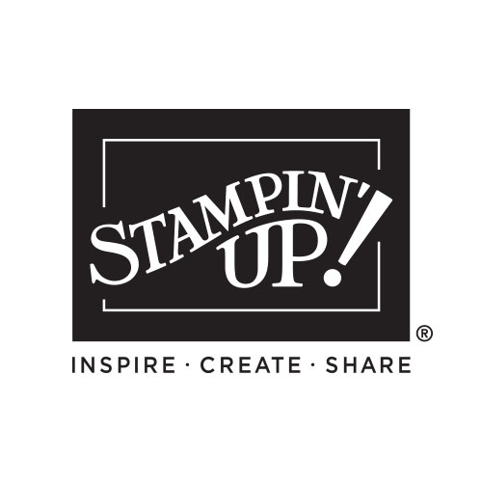

My Wish List

Name:_____________________________

January-April Mini

2025 INDEX

Table of Contents/Icons 2
Welcome 3
Message from Sara 4
Making a Difference 5
Step-by-step 6-7
Kits 8-9
Quick & Easy Options 10-19
Mix & Match 12-13
Get Inspired 14-15
Memories & More 16-17
Creativity Your Way 20-21

Product Suites 22
- Storybook Moments 23-29
- Friends of the Ocean 30-32
- Floral Delight 33-37
- Beautiful Bokeh 38-41
  - Wildflower Birthday 42-45

Stampin’ Cut & Emboss 46

Bundles 47
- Linked Together 48-49
- Memorable Blooms 50
- Darling Dinos 51
- For the Books 52
- Terrific Toadstools 53
- Hugs for Love 54

Stamps 55-61
Gathering 62
Rewards 63
Join 64
Index 65
Paper Pumpkin 66
Legal 67

Please keep this list - mark off things as you purchase them OR give this list to someone who loves you so they can purchase gifts for you!

QTY | Code | Description | Page | Price
Order Anytime! Shop Online 24/7!
Contact me with questions or to place an order:

Your Name Here
City, State Zip Code
Phone number and email address
Free ideas on my blog/website:
Blog or Website address

