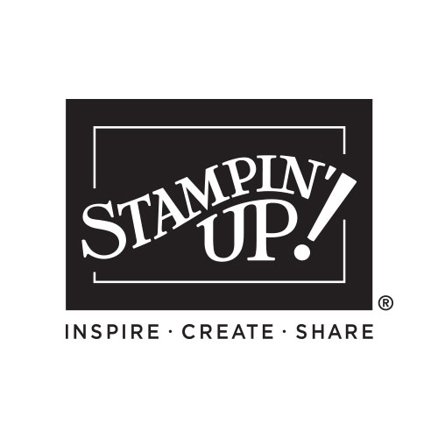

My Wish List

ANNUAL CATALOG

2024-2025 INDEX

Message from Shelli & Sara Inside Cover
Table of Contents 2-3
Step-by-Step Crafting (kits) 4-11
Quick and Easy Options 12-29
- Top Ten 16-17
- Mix & Match 18-21
- Basic Card Design 22-23
- Memories Plus 26-27
- Gift Packaging 28-29
Creativity Your Way 30-33
Suite Collections 34-55
- Mediterranean Blooms 34-35
- Take to the Sky 36-37
- To Market 38-39
- Wildly Flowering 40-41
  - Full of Life 42-43
  - Lily Pond Lane 44-45
  - Thoughtful Journey 46-47
  - Country Woods 48-51
  - Unbounded Beauty 52-55
Bundles 56-73
Encore Products 74-80
Stamping Techniques 81-91
- Cling vs Photopolymer 81
- Blocks, Stampin’ Pierce, Stampin’ Scrub 82-83
- Background Brilliance 90-91
Million Sales Achievement 92-93
A Space for Inspiration (Storage) 94-95
Reasons to Craft 96-109
Adorable Accessories 110-115
- Metallics 110-111
- Ribbon/Twine 112-113
- Embellishments 114-115
Sticky Business (Adhesives) 116-117
Crafting Techniques 118-131
- Embossing Folders 128-129
Color Theory 132-133
Color Collections (CS/ink/Blends charts) 134-139
Index 140-141
Join and Gather 142-143
Angel Policy 144
Legal 144

Please keep this list - mark off things as you purchase them OR give this list to someone who loves you so they can purchase gifts for you!

Name:_____________________________

QTY | Code | Description | Page | Price
Order Anytime! Shop Online 24/7!
Contact me with questions or to place an order:

Your Name Here
City, State Zip Code
Phone number and email address
Free ideas on my blog/website:
Blog or Website address

