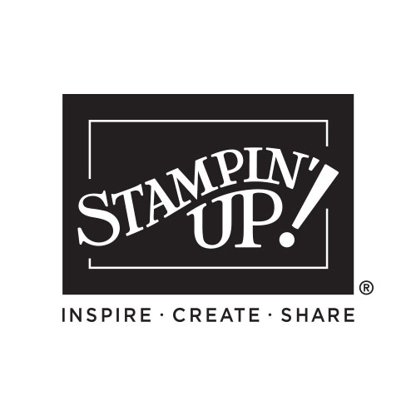

My Wish List

Name:_____________________________

January-April Mini

2024 INDEX

Table of Contents 2
Catalog Icons 2
Making a Difference 4
Message from Sara 5
Online Exclusives 6
Kits Collection 7

Product Suites
- Bee Mine 8-10
- Forever Love 14-16
- Perennial Lavender 22-25
- Lighter Than Air 32-34
  - Nature’s Sweetnes 40-43
  - Just Kiddin’ 48-50
  - Rock & Roll 54-55
  - Poetic Expressions 60-62

Indexes 66-77
Bundles 67-73
Catalog at a Glance 74-77
Host & Join 78-81
Legal 82

Please keep this list - mark off things as you purchase them OR give this list to someone who loves you so they can purchase gifts for you!

QTY | Code | Description | Page | Price
Order Anytime! Shop Online 24/7!
Contact me with questions or to place an order:

Your Name Here
City, State Zip Code
Phone number and email address
Free ideas on my blog/website:
Blog or Website address

